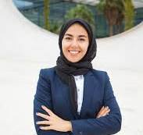

DLD Labs

Airline Management System |

Skill 02:(Programming)

**C,C++,C#(.NET),SQL**

Educational

I'm Zainab Bibi, a Computer Science student at UET Lahore. I’m passionate about coding, problem-solving, and learning new technologies to become a skilled programmer.

**Vital College,Wazirabad**

**(Completed 2024)**

Intermediate

**University of Engineering and Technology,**

**Lahore,(ongoing)**

BS Cmputer Science

(

Implemented logic circuits using gates.

Made an airline booking system in C++.

Built a C# and Oracle app for event handling.

Event Management System

Experience

Skill 01: (Basics)

**MS Office ,English Language**

Skilled

+923176340960

Zainab7576@gmail.com

Wazirabad ,Pakistasn

Contact me

About Me

NAME

Zainab Bibi